|  |  |
| --- | --- |
| WEST LONDON WASTE AUTHORITY |  |
| Report of the Treasurer and Managing Director | 22 March 2024 |
| **Finance Update January 2024** | |
| SUMMARY This report provides an update on financial and operational matters. The key points are:   * Day to day financial performance for YTD is showing a deficit largely due to 3 factors: * Contracted rates for waste disposal are higher than budgeted. * Business rates are significantly higher than budgeted. * SERC insurance being included within Supplies and Services. * There is a recommendation to roll over any borough’s unused HRRC funding into 2024/25, payable to boroughs after they achieve a new target. * There is a recommendation to roll over any unspent programme budget from the PPP income retained by the Authority, so it remains available for use in 2024/25. * Continuing to track return on investments on funded programmes. Spend has not met expectations but direct borough savings continue to be achieved. * The forecast annual position includes an estimate of PPP contract income as per the FY24/25 budget and two thirds disbursement to boroughs. * Operational performance is shown in the KPIs. Two KPIs are in amber (not on target but high likelihood of turning green before end of financial year) and three are in red (not on target and low likelihood of turning green before end of financial year). * The Treasury Management Plan to be approved continues to be low risk and demonstrates a robust financial outlook. * There were no delegated decisions to note. | |
|  | |
| **RECOMMENDATION(S)**  The Authority is asked to: -   1. Note the current financial position and forecast for 2023/24 2. Approve a reserve to carry forward unspent HRRC funding so it remains available for boroughs to use in 2024/25. 3. Approve a reserve to carry forward unspent programme budget from the PPP income retained by the Authority so it remains available for use in 2024/25. 4. Approve the Treasury Management Plan for 2024/25. 5. Note the KPIs to date. 6. Note the delegated decisions. | |

1. **Financial position – high level summary**

A summary of the financial performance for the period up to end of January 2024 and forecast to the end of the year is provided below. The summary shows how financial performance compares to the budget for both the period and the forecast for the year.



From an operational “day to day" activities perspective, the overall performance for the period shows an overspend of £19k compared to budget. The overspend on expenditure is largely due to higher Waste Transfer and Disposal costs reflective of increased prices compared to budget, in particular Lakeside’s rate which has come in at £5/tonne higher than budget. Business rates within Premises costs are significantly higher than budget, with the forecast at year end expected to be £0.86 million higher than budget.

It is also worth noting that the MRF Waste Transfer and Disposal costs are overspent by £1.6 million. This is due to the inclusion of Brent’s contract which was not budgeted. However, this cost is a nil effect to the authority as these costs are directly recovered back from the boroughs shown under income.

A spend of £0.7 million has been included under Supplies and Services for the insurance of the SERC and Transfer Stations. By the end of the financial year, this will be £0.8 million. This had not been budgeted but as it has increased substantially since 2016, needs to be realised within the financial performance. Within Employee costs, there is an unbudgeted cost of £137k which relates to pension strain costs paid to LPFA.

The deficit has been reduced due to higher Trade and Other Income which has recognised just shy of £1.0 million more than budget and dampened the overspend on expenditure mentioned above.

The Authority is forecasting to end the year on a deficit of £0.8 million. Along with the above costs, this also includes consultancy fee spend to be incurred in the remaining two months of the financial year as the funded programmes start to make some traction, as well as for legal advice around various matters. There is also an additional £0.1 million accrued for a potential insurance claim which the Authority could be liable to pay. The audit fee for 2023/24 has also been included within the year end forecast at just over £0.1 million.

Considering the overspend on budget within business rates of £0.8m, Lakeside contractual rate of £0.4m, SERC and Transfer Stations insurance of £0.8m and the pension strain costs of £0.1m, the total deficit would be £2.1m. However, the Authority has put controls into place to bring spend down where possible, bringing the forecast total deficit to £0.8 million. These controls have reduced spend where possible but not detrimental to the service the Authority provides.

Significantly, in other activities, PPP income for the year has been estimated at £6.3 million. The volatile electricity market and impact of any windfall tax create some uncertainty in this estimate and the value will only become clear in June 2024 when figures are finalised and thereafter paid over to the Authority. Two thirds will be passed on to boroughs in accordance with the Finance Strategy by September 2024. With the Authority receiving this PPP income, and disbursing two thirds to the boroughs, the overall forecast position for the Authority is a surplus of £1.3 million.

Included within the budget monitoring, is also a disbursement of excess reserves from the previous financial year of £3.3m which was presented in June 2023 as part of the 2022/23 draft outturn report. To note, the excess revenue share from the PPP contract which relates to 2022/23 has now been received (£19.1m). Two thirds of this have been paid to the boroughs in disbursements in July 2023.

The main variances are detailed in the standard breakdown in Appendix 1 which separates out the main types of waste streams and distinguishes between PAYT and FCL activities. Notable items of detail from Appendix 1 include:

Looking at the PAYT waste forecast, the overall residual waste variance of £0.1 million is made up of slightly higher than budgeted tonnages coupled with higher than budgeted contractor prices (due to inflation). The higher waste volumes are also reflected in the PAYT levy variance (£0.6 million) which shows actual rebates paid from boroughs to WLWA for higher than budgeted tonnages.

Secondly, in terms of FCL waste, there has been higher than budgeted HRRC volumes in particular mattresses, leading to higher waste transport and disposal forecast costs against budget totalling £0.3 million.

The Authority’s level of trade and other income is healthy and forecast to out-perform the budget by just under £1.0 million.

The forecast anticipates that the remainder of the funds for the improvements to borough HRRC’s will not be spent by boroughs. These have been rolled forward once before via reserves, with an expectation that improving diversion would be delivered in 2023/24. During the financial year, there was an agreement with the Environment Directors about increasing the target to 50% diversion from residual to receive the funds.

Over the course of 2023/24, some boroughs have demonstrated further performance improvements without spending much of the available funding. However, there is much more to do to drive down HRRC residual waste per household. The Authority anticipates that the balance of funds remaining unspent will be an investment to drive further performance improvements. The Authority has reviewed possible solutions and recommend retaining the remaining funds, via reserves, to be paid over to the boroughs when clear, challenging and time-bound performance standards have been met. If this proposal is agreed by members, the agreed savings to be achieved and the performance improvement targets will be reported to members in June 2024.

The Authority will also set aside reserves for any unspent programme budget remaining at the end of 2023/24 from the PPP income, so it remains available for use in 2024/25. This is due to the delays in receiving savings targets from boroughs in relation to work that can be done with them on the programmes. The Authority has been able to engage with some boroughs in 2023/24 and either delivered savings or received savings targets. In the first quarter of 2024/25, the Authority is expecting to meet with the remaining boroughs that have not yet engaged to discuss potential savings targets to be achieved.

1. **KPIs for 2023/24**

Appendix 2 summarises the performance to the end of January, in both a summary table, and significant KPIs being shown graphically with a year-on-year trend.

Most indicators are on target (green) and the performance is reflected in the RAG rating and commentary.

There are two KPIs in amber. Turnaround times have been impacted by fires at both transfer stations, and crane issues at Victoria Road. Overall £/tonne is impacted by inflationary pressures on contractor fees.

People development is on red due to the likelihood of the full year target not likely to be achieved. This KPI has been impacted by leavers within the Authority but is now increasing as processes are being implemented to record training and new joiners are starting. However, it is unlikely the target of 500 for the full year will be met.

Food waste – kg per person is in red due to tonnages remaining flat, but the population increasing. Staff turnover is red due to ten leavers’ year to date. Recruitment has been difficult in the current market, but this is being worked on.

The graphs in Appendix 2 visualise the performance of the Authority and show year on year trends. The graphs demonstrate that waste has been reducing over the years.

It is worth noting that from time to time the performance for a particular indicator may slip into amber or red, but the performance will be managed, and actions undertaken to bring the indicator back to standard during the year. Additionally, given the cumulative nature of each individual indicator, an indicator is more likely to slip into amber or red in the early months.

1. **Delegated decisions**

To provide further transparency of operational arrangements, this standard section of the report summarises any significant financial decisions made since those reported to the last Authority meeting and not reported elsewhere in the agenda.

There have been none to note.

1. **Treasury Management**

The plan for 2023/24 continues the low risk and very simple approach of recent years.

There are no significant capital spending plans and no plans for any new borrowing. Therefore, the focus will be on managing cash to ensure adequate liquidity for day-to-day operations whilst also using low risk options to deliver a return.

The current arrangements (a service level agreement with Ealing Council) provide both a return and quick access to cash. The arrangement also allows the Authority to tap into money market rates of Ealing Council’s high rated counterparties (UK government gilts, large UK high street banks) offering a better return i.e. funds can be placed for fixed periods to achieve better returns.

The CIPFA Prudential Code prescribes a range of indicators that must be reported. These are more pertinent to organisations with complex treasury management arrangements, however, are provided in the table in Appendix 3. This table demonstrates that the Authority’s capital expenditure plans are prudent, affordable, and sustainable. It also demonstrates that decisions are taken with a full understanding of their risk and their management. It is worth noting that the historic capital expenditure and borrowing in relation to the construction of the Energy from Waste plant, accounts for most of the figures in this table.

Similarly, the Minimum Revenue Provision (MRP) identifies that the Authority is required to pay off an element of the accumulated capital spend each year (CFR in the Prudential Code table above) through a revenue charge. The current approach uses 4% of capital, the CIPFA standard method for calculating MRP to provide for a reduction in the borrowing need over the asset’s life.

The impact of treasury management activities is reflected in the Authority’s long term financial plans. This illustrates a strong financial outlook and in particular: how all capital spend will be paid off through revenue charges; how the Authority will only see lower than inflation rises in costs and therefore levies; and how all borrowing will be repaid whilst maintaining good levels of liquidity – all key requirements of the CIPFA codes.

1. **Financial Implications.**

These are detailed in the report.

1. **Staffing Implications**

None.

1. **Legal Implications**

None.

1. **Impact on Carbon Reduction**

None.

1. **Impact on Joint Waste Management Strategy**

Improvements to financial management in the Authority will continue to ensure that the Authority addresses policies of the JMWMS.

|  |  |
| --- | --- |
| Contact Officers | Sapna Dhanani, Finance Manager  [sapnadhanani@westlondonwaste.gov.uk](mailto:sapnadhanani@westlondonwaste.gov.uk)  Ian O’Donnell, Treasurer  [ianodonnell@westlondonwaste.gov.uk](mailto:ianodonnell@westlondonwaste.gov.uk)  Emma Beal, Managing Director  [emmabeal@westlondonwaste.gov.uk](mailto:emmabeal@westlondonwaste.gov.uk) |

**Appendix 1**



**Appendix 2**



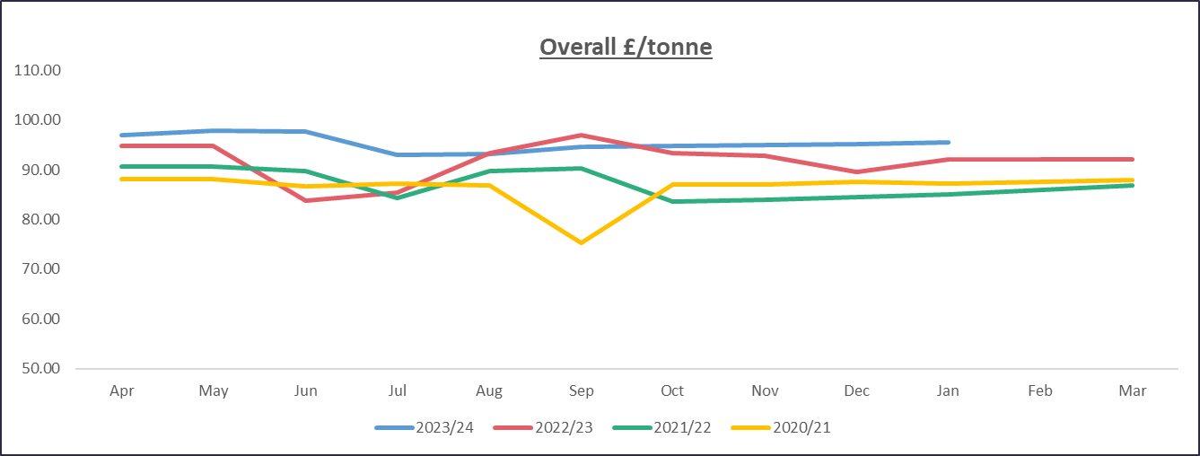

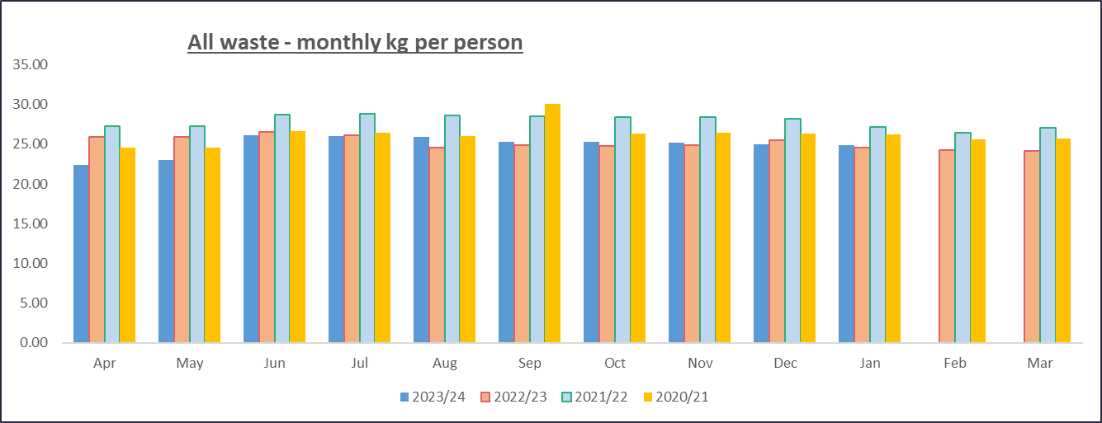

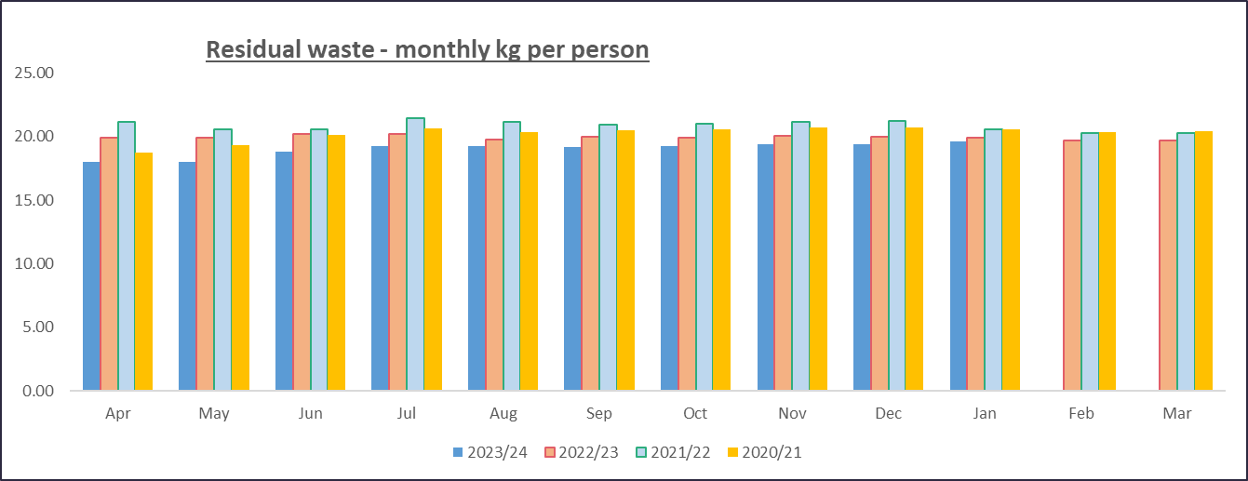

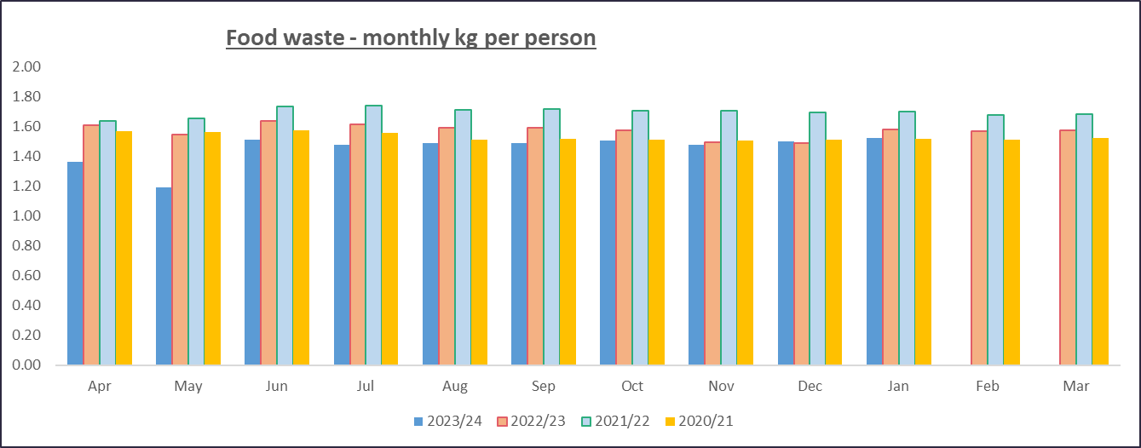

**Appendix 3**

